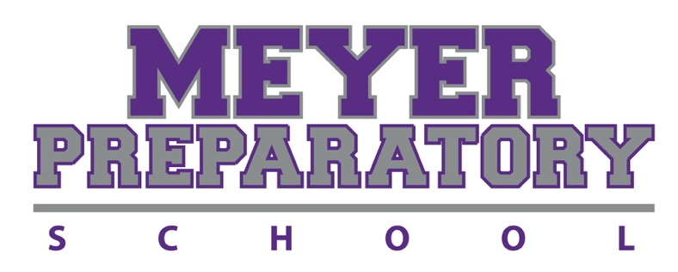

We have implemented an easier process for our families to apply for financial assistance.
FACTS Grant & Aid Assessment will be conducting the financial need analysis for Meyer Prep for the upcoming 2023-2024 school year.

PLEASE READ THE INSTRUCTIONS IN ITS ENTIRETY

The financial assistance (FA) process is strictly confidential. By submitting your financial assistance packet, you agree to the terms and conditions of the financial assistance policies and procedures. Financial need is determined by the ability to meet educational expenses, not on a willingness to pay. Awards are annual, contingent upon continuing eligibility and availability of funds.

DEADLINE

EXISTING MEYER PREP FAMILIES: The FA application is due no later than January 17, 2023.

NEW FAMILIES: The FA application is due one week from the date the signed Enrollment and Tuition Agreement is submitted.

All financial assistance applications submitted after the deadline will be reviewed on a first-come, first-serve basis. Adhering to the deadline and responding to missing information is critical.

Financial assistance is not guaranteed.

To apply for financial assistance use the following FACTS link:

https://online.factsmgt.com/signin/3TRJG

Families applying for financial assistance will need to complete an application and submit the necessary supporting documentation to FACTS Grant & Aid Assessment using the following link: LINK

THINGS TO KNOW BEFORE COMPLETING THE APPLICATION:

If you are new to FACTS, "Create Your Account".
If you have an existing FACTS account and have already created a user account, please select "Sign In" and use your existing username and password.
- Click on the "Start Application" link.
- Select the appropriate school year.
- Complete the steps as prompted.

Once the application has been submitted, print the provided coversheet that shows all the required documents needed to complete your application.

Both parents’ information who are required to sign the Enrollment and Tuition Agreement must be included on the Application.
Note: The application will ask for Applicant and Co-Applicant.
Parent #1 will be the Applicant and Parent #2 will be the Co-Applicant.

If parents are not married, two separate Financial Assistance Applications are required.

In addition to Meyer Prep’s financial assistance, all families are required to apply to Step Up for Students for the Family Empowerment income-based scholarship.
Link: www.Stepupforstudents.org.
DO NOT wait to hear if you are awarded Step Up for Students before applying for Meyer Prep’s financial assistance.

Financial Assistance (FA) documents will not be accepted or processed until the Enrollment & Tuition Agreement has been signed and all monies due to Meyer Prep are paid and up to date.
AFTER COMPLETING THE ONLINE APPLICATION, YOU WILL NEED TO UPLOAD ALL REQUIRED SUPPORTING DOCUMENTATION.

The following supporting documents are required to complete the application process:
• IRS 2021 & 2022 Federal Income Tax Return, including all supporting schedules. If applicant and co-applicant file separately, we require both tax returns for the same tax year.

• Copies of all 2022 W-2 Wage and Tax Statements for both the applicant and co-applicant.
NOTE: If you are applying before you have received all the current year W-2 Wage and Tax Statements, please submit them as soon as they become available.

• Copies of all supporting 2022 tax documents if you have business income/loss from any of the following:
- Business - send Schedule C or C-EZ and Form 4562 Depreciation and Amortization
- Farm - send Schedule F and Form 4562 Depreciation and Amortization
- Rental Property - send Schedule E (page 1)
- S-Corporation - send Schedule E (page 2), Form 1120S (5 pages), Schedule K-1 and Form 8825
- Partnership - send Schedule E (page 2), Form 1065 (5 pages), Schedule K-1 and Form 8825
- Estates and Trusts - send Schedule E (page 2), Form 1041 and Schedule K-1

IMPORTANT: If you file a tax return but do not have W-2 wages because you are self-employed, you will be required to submit a copy of your 2021 & 2022 Federal Form 1040 Tax Return.
• Copies of all supporting documentation for household Non-Taxable Income such as: Social Security Income, Welfare, Child Support, Food Stamps, Workers’ Compensation, and Temporary Assistance for Needy Families (TANF).
If you do not file a tax return, you are required to provide documentation of all income received.

All documentation received is imaged upon receipt and then destroyed.

You may log in to your FACTS user account to review the status of your application.

If you are applying after the deadline, contact Dena Decker to ensure that your application will be accepted.
A non-refundable application fee is required before your application will be submitted.

FA COMMITTEE’S DECISION:

- If financial assistance is awarded, parents will receive a revised Enrollment and Tuition Agreement through DocuSign. Both parents (if applicable) are required to sign within one week of the revision being sent or the financial assistance will be forfeited.
- If financial assistance is not awarded, parents will receive an Enrollment and Tuition Agreement through DocuSign. Parents will have one week to send the Business Office a written statement (1) if the student(s) will not attend the 2023-2024 school year or (2) appeal the decision. If the Business Office does not receive written notification by the deadline the agreement will be FULL PAY.

If ANY scholarship and/or grant is awarded after the family accepts the financial assistance, the committee may adjust the amount of the award.

The process of applying for and receiving financial assistance is kept strictly confidential. It is our intent to make this assistance available as broadly and fairly as possible.

You will lose all financial assistance, and reimbursement of full payment will be required, if it is disclosed that you discussed ANY part of the financial assistance process including but not limited to the amount, terms or general information of your financial assistance with anyone but the Financial Assistance Department.

For questions please contact:
Dena Decker ddecker@meyerprep.org

Revised 10/19/2022

